Freud in the Media Assignment
Now that you’ve had several opportunities to explore Freud’s Defense Mechanisms, I would like you to apply them to a media sample of your choice. Pick a character from TV or a Movie, and use psychoanalysis to explain his/her actions. Include pictures of video clips to support your analysis.
Choose your character carefully. I want this assignment to be something that you enjoy, as well as an opportunity to showcase your understanding of Freud’s Psychoanalytic Theory.
On your Unit 3 page in your ePortfolio, I would like you to include the following under the heading “A psychoanalysis of _____________________”

- Identify what is happening with the Id, Ego and Superego to create the tension necessary for the defense mechanisms (Rationalization, Repression, Denial, Projection, Reaction formation, Regression, Displacement, Sublimation).
- You must include at least 5 of the 8 defense mechanisms in your analysis.
- Describe the situation in detail (supported with pictures and video clips). Explain the defense mechanisms present in the story. You may need to use several scenes or episodes so that you can represent at least 5 of the mechanisms.
- This assignment should be completed in paragraph form, with complete sentences, worthy of a grade 12 assignment. Aim for approximately 500 words.
The rubric with which I will assess your work is on the back of the page. This is a significant assignment and I will provide you with 3 classes to work. Please bring your own computer if you have one, and head phones.
/30
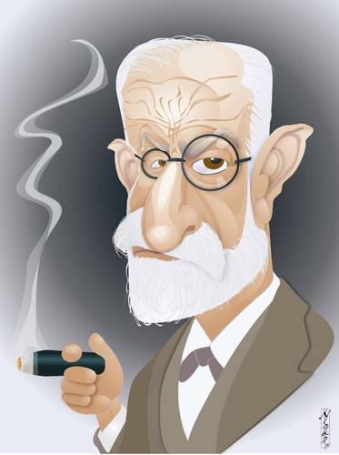
Freud in the Media Assignment Rubric | Does not meet | Minimally meets | Meets | Exceeds
Inclusion of criteria  (pictures, description, recommended length, analysis and reflections | - No attempt to include all criteria | - Most of the criteria are met | - All criteria are met
Analysis  (responses to content knowledge questions, application of course material) | - None included | - Included but answers are incorrect  - Only basic understanding of concepts is displayed | - Included and correct  - Demonstrates understanding | - Demonstrates nuanced understanding  - Analysis is complete and thoughtful
Overall Assignment  (personal expression, voices personal interpretations, extends learning, demonstrated critical thinking, professional quality, care & effort) | - Unedited, work submitted is in rough draft  - No attempt at a Professional and academic tone  - No apparent pride in work | - Minimal editing completed  - Inconsistent tone  - Does not read like a grade 12 assignment | - Uses a consistent academic tone  - Worthy of a Grade 12 academic assignment | - Consistent Professional and academic tone  - Displays clear effort and pride in work  - Worthy of a grade 12 assignment  - WOW

/30

